# 

# 

**Department of Computer Science and Engineering**

**University of Dhaka**

**Project Report**

CSE2211 - Database Management Systems-I

2nd Year 2nd Semester - 2018

**Project Title**

**Soccer Database Management System**

**Submitted By**

Name: Pankaj Chandra Kar

Registration No: 2016-814-440

Roll No: JN-49

# 

# 

**Introduction** **3**

**Descriptions** **4**

**Design Diagrams** **5**

**Environment of Implementation** **6**

**Application of the Database** **7**

**Conclusions and Discussions** **8**

# 

# **Introduction**

Soccer is the most popular sport in the world. It contains an enormous database. As we can see from different online source that there are huge amounts of data. From that concept I wanted to do something like that.

We have learnt RDBMS. Which helps us to create relations between tables. RDBMS is extremely helpful to build a database on Soccer. So I planned to do it by RDBMS. Because players, matches, venues etc. can be different tables which have relations between them like a match is played in a venue.

# Descriptions

[Describe your project idea clearly in this section. Add the main features, objectives, motivation as well as necessity and importance of your project in this section. Use multiple sub-sections if needed.]

I wanted to make a database to store the information of the players, matches etc. So In order to that main features are:

1. All info of the player like match by match position,

Club, value etc.

1. Full detail about a match with the opposition name and venue.
2. Coaches with their club and info of their management of a club.
3. Clubs with their league.

Main goal was to take all possible types of matches like club matches with players on match by match position.

People can easily use this database to find all info about a specific match, players played on that match etc. We can also find total number of wins, draws or loses of a club. Info about Management of club by a coach can be found. Which players are high rated, which coaches are free can be found from this database.

# Design Diagrams

Fig: ERD

I have assumed that all coaches may not manage a club. So manages relation is added. Besides all player may not play in same position, it can differ from match to match. If a player plays in a club then salary is added. A club must be part of a league.

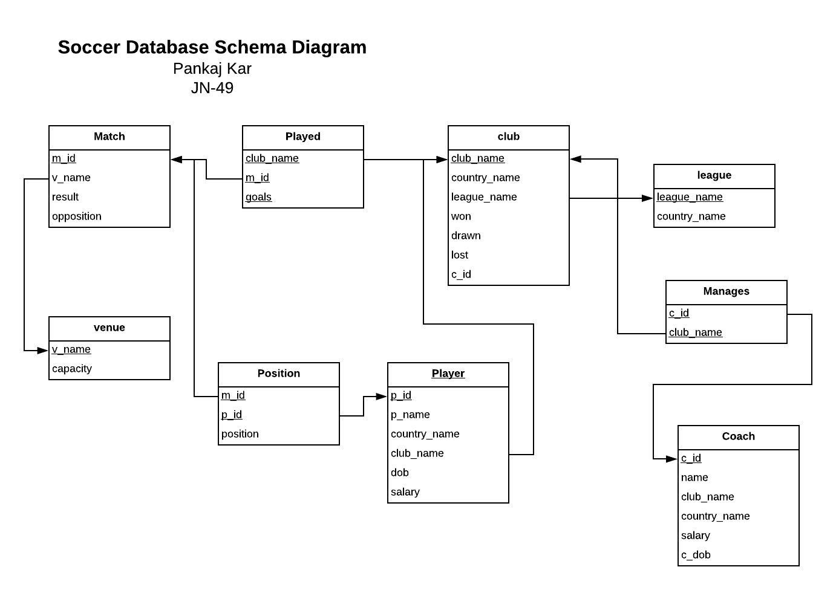

Fig: Schema.

All the relations are converted to table in this schema. We have added a table ‘position’ for match by match position. Besides there is a direct link between venue and match.

# Environment of Implementation

Overall I have felt much comfortable using oracle 11g. It’s really easy to use. Besides localhosts helped a lot. Very user friendly environment. SQL is much easier for oracle.

I haven’t used other platforms because I don’t know much about those. I have used MySQL little bit. But It seems oracle is much suitable and SQL is much easier on oracle.

# Application of the Database

**Application Scope: Name of the player who played at least one match.**

SQL query:

*select p_name*

*from position natural join player*

*where position is not null*

Output:

|  |
| --- |
| P_NAME |
| Messi |
| Pique |
| Umtiti |
| Coutinho |
| Malcom |
| Arthur |
| Suarez |
| Jordi Alba |
| Ter Stegan |

**Application Scope:Name of the highest payed player.**

SQL query:

*select p_name, salary*

*from player*

*where salary >=(select max(salary) from player*

*)*

OutPut:

|  |  |
| --- | --- |
| P_NAME | SALARY |
| Neymar | 90000 |

**Application Scope: League which has maximum number of clubs**

Sql Query:

*select league_name*

*from(*

*select league_name, count(club_name) as c*

*from club*

*group by league_name*

*)*

*where c>= ( select max(c)*

*from(*

*select league_name, count(club_name) as c*

*from club*

*group by league_name)*

*)*

OutPut:

|  |
| --- |
| LEAGUE_NAME |
| Premier League |

**Application Scope: Show the country with its number of players**

Sql Query:

*select country_name, count(p_id)*

*from player*

*group by country_name*

|  |  |
| --- | --- |
| COUNTRY_NAME | COUNT(P_ID) |
| URU | 2 |
| CAM | 1 |
| BRA | 14 |
| FRA | 7 |
| WAL | 1 |
| COL | 1 |
| ICO | 1 |
| ENG | 9 |
| ITA | 9 |

**Application Scope: Show the number of Argentine players play in premier league.**

SQL Query:

*select p_name*

*from player natural left join club*

*where country_name='ARG' and club_name in (select club_name from club where league_name='Premier League')*

Output:

|  |
| --- |
| P_NAME |
| Aguero |
| Otamendi |
| Rojo |

**Application Scope: Show the name of the coaches who doesn't manage any clubs**

SQL Query:

*select distinct name*

*from coach natural left join manages*

*where club_name is null*

Output:

|  |
| --- |
| NAME |
| Klopp |

**Application Scope: List of the player who played in CF position**

SQL Query:

*select p_name*

*from player natural join position*

*where position='CF'*

output:

|  |
| --- |
| P_NAME |
| Messi |
| Benzema |
| Lukaku |
| Reneira |
| Mangala |
| Otamendi |
| Dybala |
| Cancelo |
| Mauri |

**Application Scope: List of the venues with no of matches in it**

SQL Query:

*select v_name, count(m_id) as NO_of_Matches*

*from match natural right join venue*

*group by v_name*

Output:

|  |  |
| --- | --- |
| V_NAME | NO_OF_MATCHES |
| Allianz Stadium | 0 |
| Anfield Stadium | 0 |
| Camp Noe | 1 |
| Etihad Stadium | 0 |
| Old Trafford | 1 |
| Parc Des Princes | 1 |
| San Siro | 1 |
| Santiago Bernabue | 0 |

**Application Scope:** **Number of player play in premier league**

SQL Query:

*select count(p_id)*

*from player p join club c on p.club_name=c.club_name*

*where league_name='Premier League'*

output:

|  |
| --- |
| COUNT(P_ID) |
| 24 |

# Conclusions and Discussions

[In this section, you have to conclude your report with the limitations, future possibilities of this project. In addition, you have to keep a discussion on the overall work of the project.]

# 